8th Lab – RIP based VLSM Network Topology

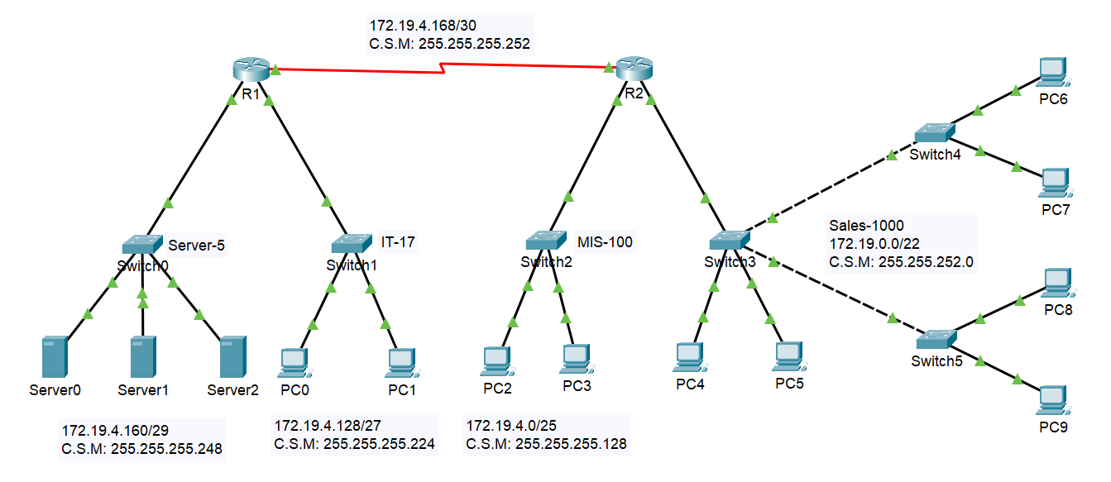
Topology
- Network Summary
Network Name | Subnet | Description
Server-5 | 172.19.4.160/29 | Server0–Server2
IT-17 | 172.19.4.128/27 | PC0–PC1
MIS-100 | 172.19.4.0/25 | PC2–PC3
Sales-1000 | 172.19.0.0/22 | PC4–PC9
Serial Link | 172.19.4.168/30 | R1 ↔ R2
- Router Configuration
Router R1
Router> enable
Router# configure terminal
Router(config)# hostname R1
R1(config)# interface fastethernet 0/0
R1(config-if)# ip address 172.19.4.161 255.255.255.248
R1(config-if)# no shutdown
R1(config-if)# exit
R1(config)# interface fastethernet 0/1
R1(config-if)# ip address 172.19.4.129 255.255.255.224
R1(config-if)# no shutdown
R1(config-if)# exit
R1(config)# ip dhcp pool IT
R1(dhcp-config)# network 172.19.4.128 255.255.255.224
R1(dhcp-config)# default-router 172.19.4.129
R1(dhcp-config)# exit
R1(config)# interface serial 0/0/0
R1(config-if)# ip address 172.19.4.169 255.255.255.252
R1(config-if)# clock rate 148000
R1(config-if)# no shutdown
R1(config-if)# exit
R1(config)# router rip
R1(config-router)# version 2
R1(config-router)# network 172.19.4.160
R1(config-router)# network 172.19.4.128
R1(config-router)# network 172.19.4.168
R1(config-router)# no auto-summary
R1(config)# Ctrl+Z
R1# write

Router R2
Router> enable
Router# configure terminal
Router(config)# hostname R2
R2(config)# interface fastethernet 0/0
R2(config-if)# ip address 172.19.4.1 255.255.255.128
R2(config-if)# no shutdown
R2(config-if)# exit
R2(config)# ip dhcp pool MIS
R2(dhcp-config)# network 172.19.4.0 255.255.255.128
R2(dhcp-config)# default-router 172.19.4.1
R2(dhcp-config)# exit
R2(config)# interface fastethernet 0/1
R2(config-if)# ip address 172.19.0.1 255.255.252.0
R2(config-if)# no shutdown
R2(config-if)# exit
R2(config)# ip dhcp pool Sales
R2(dhcp-config)# network 172.19.0.0 255.255.252.0
R2(dhcp-config)# default-router 172.19.0.1
R2(dhcp-config)# exit
R2(config)# interface serial 0/0/1
R2(config-if)# ip address 172.19.4.170 255.255.255.252
R2(config-if)# no shutdown
R2(config-if)# exit
R2(config)# router rip
R2(config-router)# version 2
R2(config-router)# network 172.19.4.0
R2(config-router)# network 172.19.0.0
R2(config-router)# network 172.19.4.168
R2(config-router)# no auto-summary
R2(config)# Ctrl+Z
R2# write
- Configuration Server and PC (PC0–PC9):
In Static: Server0, Server1, Server2 (Server-5 Network)
- Subnet: 172.19.4.160/29
- IPs: 172.19.4.162, .163, .164
- Subnet Mask: 255.255.255.248
- Gateway: 172.19.4.161
Click on each PC (e.g., PC0).
- Go to Desktop tab > IP Configuration.
- Select DHCP.
- The PC will receive:
- IP Address
- Subnet Mask
- Default Gateway (from router)

